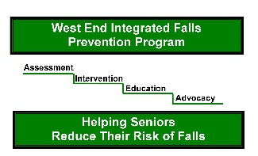
WEST END INTEGRATED FALLS PREVENTION PROGRAM
Phone: 613-820-4922 Fax: 613-288-3407
REFERRAL CRITERIA : Please check that client meets ALL criteria
o At least 1 indoor or multiple outdoor falls in the past year  o 75 years of age or older  o Live in their own home or in a retirement home, NOT living in long term care facility  o Able and motivated to take action to reduce falls | o NOT currently receiving duplicating services with The Home & Community Care Support Services (formerly known as the Champlain LHIN) for therapy services or the Geriatric Day Hospital/Clinic  o Client/caregiver is aware of and consents to referral
Client information
Name: | DOB: (yyyy/mm/dd) | Gender:
Street address:  *This program is only funded for certain areas in the West end of Ottawa | City: | Postal code:
Phone(s): | Preferred Language:
Cognition
Has the client been diagnosed with a cognitive impairment?
o No o Do not know
o Yes - Diagnosis: _________________________________
Caregiver is available to attend all appointments o Yes o No
Caregiver’s name: ______________________________________ Phone(s): _________________________________
FALLS
Number of indoor falls: 0 1 2 3 4 5+ | Number of outdoors falls: 0 1 2 3 4 5+
Brief description of fall(s): | Brief description of fall(s):
PAST MEDICAL HISTORY | MEDICATIONS
Primary Care Provider
Name: | Phone: | Fax:
Street address : | City: | Postal Code:
Referral source o Primary care provider as above
Name and Title: | Phone: | Fax:
Organization: | Date of Referral:
Incomplete referrals will be returned to the referral source

